Report on the Calibration of LiF:Mg,Cu,P (MCP) Thermoluminescent Detectors



Institute of Nuclear Physics, Polish Academy of Sciences

To: dr. hab Paweł Bilski
Date: 27 April 2026
From: Nigus Alene Assefa, (PhD Student)
Subject: Progress Report on the Initial Calibration of LiF:Mg,Cu,P Dosimeters
1. Introduction
This report summarizes the experimental work conducted on the characterization of LiF:Mg,Cu,P (MCP) thermoluminescent detectors. The primary objective was to determine the Individual Response Factors (IRF) for a batch of detectors and to establish a reliable calibration of their response to beta radiation from a Sr-90/90Y source at different exposure times and dose rates. The work was carried out under the supervision of Dr. Anna Mrozik and follows standard procedures for TLD handling and processing at the IFJ PAN.
LiF:Mg,Cu,P is a highly sensitive thermoluminescent material that has become a cornerstone in modern dosimetry, particularly for personal and environmental monitoring [1, 2]. Since its development in the late 1970s and subsequent refinement for reusability in the 1980s, MCP has been recognized for its superior dosimetric properties compared to its predecessor, LiF:Mg,Ti (TLD-100) [3, 4]. The high sensitivity, linear dose response, and low fading characteristics make this material particularly suitable for precise dosimetric applications [1, 5].
The experimental protocol consisted of three main phases: (1) initial annealing and calibration of a subset of detectors with a 137Cs gamma source, (2) irradiation of detectors with weak and strong beta sources at varying exposure times, and (3) determination of IRF through uniform gamma irradiation of all detectors. This report presents the results obtained from these experiments, including glow curve analysis, IRF distribution, beta source response, dose rate calculations for both the Sr-90/90Y and 137Cs sources, and decay corrections for future experiments.

2. Materials and Methods

2.1. Detectors
LiF:Mg,Cu,P (MCP) detectors were used in this study. The detectors are in the form of pressed pellets. This material exhibits a main dosimetric peak at approximately 210–220°C (Peak 4), which is used for dosimetry applications [1, 4].

2.2. Annealing and Readout
All annealing procedures were performed at 240°C for 10 minutes to erase residual signals [3, 4]. This annealing regime is recommended for MCP detectors to restore consistent sensitivity. Prior to each readout, detectors were preheated at 100°C for 10 minutes to remove low-temperature peaks (Peaks 1, 2, and 3), which are unstable and prone to fading [1, 5]. Readout was performed using the Harshaw 3500 TL reader with a heating rate of 2°C/s to a maximum temperature of 300°C.

2.3. Experimental Procedure
2.3.1. Detector Preparation (13 March 2026)
All detectors were annealed at 240°C for 10 minutes to establish a consistent baseline.

2.3.2. Calibration Set Irradiation (13 March 2026)
Eight detectors were sent to the calibration laboratory for irradiation with a 137Cs gamma source.
2.3.3. Beta Source Irradiations (16 March 2026)
The remaining detectors were divided into four groups:
Weak source: 20 detectors irradiated for 10 seconds, 20 detectors for 30 seconds
Strong source: 20 detectors irradiated for 10 seconds, 20 detectors for 15 seconds
2.3.4. First Readout (17 March 2026)
All detectors were preheated at 100°C for 10 minutes and read out to obtain the initial TL signals.
2.3.5. Individual Response Factor Determination (19 March 2026)
All detectors were re-annealed at 240°C for 10 minutes. The entire batch of detectors was then irradiated uniformly with the 137Cs gamma source. The irradiation was performed at a distance of 200 cm for 21 hours, 27 minutes, and 40 seconds. Following irradiation, the detectors were preheated at 100°C for 10 minutes and read out. This uniform irradiation allows for the determination of Individual Response Factors (IRF) to correct for chip-to-chip variations in sensitivity.
2.3.6. Data Collection (23 March 2026)
The data from the Harshaw 3500 reader were collected and analyzed. This included the TL signals from the uniform gamma irradiation (used for IRF calculation) and from the beta irradiations.

3. Results

3.1. Glow Curve
Figure 1 shows a representative glow curve of an MCP detector irradiated to gamma radiation. The glow curve was recorded during the readout on 23 March 2026 using the Glow View feature of the Harshaw 3500 reader software, which displays TL signal intensity as a function of temperature in real time. The main dosimetric peak appears at approximately 210°C, consistent with the known characteristics of LiF:Mg,Cu,P [1, 4]. The low-temperature region (below 100°C) shows minimal signal, confirming that the preheating step at 100°C effectively eliminated unstable peaks. The high-temperature region above 260°C shows negligible residual signal, indicating that the readout temperature of 260°C was sufficient to empty the dosimetric traps [2]. Glow View further enabled real-time verification of consistent peak position and shape across all detectors, confirming batch uniformity and proper reader function, while also allowing monitoring of potential PMT saturation during high-dose measurements [2, 4].
Figure 1: Representative Glow Curve of LiF:Mg,Cu,P Detector
Condition: Gamma irradiation, preheated at 100°C for 10 min, readout to 300°C at 2°C/s.

3.2. Individual Response Factor Determination
From the uniform gamma irradiation of all detectors, the average TL signal and standard deviation were calculated. The IRF for each detector was determined by normalizing its signal to the batch average. This normalization allows for more precise and accurate dose determination by correcting for chip-to-chip variations.
The IRF values range from a minimum of 0.876 to a maximum of 1.158. For a selected group of detectors with IRF values in the range of 0.95 to 1.05, a graph was prepared showing the distribution of individual response factors relative to the batch mean.

Figure 2: Individual Response Factors (IRF) for selected MCP detectors in the range of 0.95–1.05.
Each point represents the sensitivity of a single detector normalized to the batch average. IRF = 1.00 indicates average sensitivity.

3.3. Beta Source Response (Weak Source)
The response of detectors to the weak beta source (Sr-90/90Y) at exposure times of 10 seconds and 30 seconds is presented in Table 1. Both raw (uncorrected) and IRF-corrected TL signals are shown.
Table 1: Weak Beta Source Response (Sr-90/90Y)
Parameter | Exposure Time | TL Signal (Raw) |  | TL Signal (IRF-Corrected)
Average | 10 seconds | 19662049 |  | 19771605
 | 30 seconds | 61659948 |  | 60527928
Standard Deviation | 10 seconds | 878158 |  | 620621
 | 30 seconds | 2122357 |  | 4174619
%RSD | 10 seconds | 4.46 |  | 3.13
 | 30 seconds |  | 3.44 | 2.62
The ratio of the 30-second signal to the 10-second signal is 3.08 for both raw and corrected values, close to the expected ratio of 3.0.

3.4. Beta Source Response (Strong Source)
The response of detectors to the strong beta source at exposure times of 10 seconds and 15 seconds is presented in Table 2.
Table 2: Strong Beta Source Response (Sr-90/90Y)
Parameter | Exposure Time | TL Signal (Raw) | TL Signal (IRF-Corrected)
Average | 10 seconds | 29018551774 | 28863016940
 | 15 seconds | 45556452403 | 46206028684
Standard Deviation | 10 seconds | 1625274041 | 1268869313
 | 15 seconds | 2126014311 | 1578134703
%RSD | 10 seconds | 5.60 | 4.39
 | 15 seconds | 4.66 | 3.41
The ratio of the 15-second signal to the 10-second signal is 1.58 for both raw and corrected values, close to the expected ratio of 1.5.

3.5. Gamma Calibration Response
The eight calibrated detectors were irradiated at the calibration laboratory using a 137Cs gamma source. The irradiation was performed under reference conditions to establish a traceable calibration for the detector batch. The air kerma (K_air) delivered to the detectors was determined by the calibration laboratory. Air kerma represents the kinetic energy released per unit mass in air by indirectly ionizing radiation and is the fundamental dosimetric quantity for gamma radiation calibration.
Average corrected signal: 53959499 a.u.
Standard deviation: 601317
%RSD: 1.1%

3.6. Dose Calculation for Beta Irradiations
Using the calibration factor derived from the uniform gamma irradiation of all detectors, the TL signals from the beta irradiations were converted to air kerma (K_air). The calibration factor was calculated from the average corrected signal of the uniform gamma irradiation.
Table 3: Calculated Relative Responses for Beta Irradiations (Based on Gamma Air Kerma Calibration)
Source | Exposure Time (s) | IRF-Corrected TL Signal (a.u.) | Calculated Kerma (mGy) | Kerma Rate (mGy/s)
Weak | 10 | 19771605 | 0.38 | 0.038
Weak | 30 | 60527928 | 1.16 | 0.039
Strong | 10 | 28863016940 | 592.22 | 59.22
Strong | 15 | 46206028684 | 948.07 | 63.20
Strong 5 57131999 264.69 52.93
Strong 10 129749466 601.14 60.11

The calculated kerma rates show good consistency:
Weak source: 0.038–0.039 mGy/s (average 0.0385 mGy/s)
Strong source: 59.22–63.20 mGy/s (average 61.21 mGy/s)

4. Source Decay Calculations

4.1. Sr-90/90Y Beta Source Decay
The Sr-90/90Y source decays with a half-life of 28.8 years for Sr-90. Y-90, the daughter product, has a half-life of 64 hours (2.67 days) and quickly reaches secular equilibrium with the parent. Therefore, the effective decay of the source is governed by the half-life of Sr-90 (28.8 years) [6].
From our experimental measurements in March 2026, the kerma rates for the weak and strong Sr-90/90Y sources were determined as:
Weak source: 0.038–0.039 mGy/s (average 0.0385 mGy/s)
Strong source: 59.22–63.20 mGy/s (average 61.21 mGy/s)
These values represent the reference kerma rates at time t=0 (19 March 2026).
The kerma rate at any future time t (in years) can be calculated using the exponential decay law [6]:
Where:
₀ ​is the kerma rate at the reference date (March 2026)
T_{1/2}​=28.8 years (half-life of Sr-90)
‘t’ is the time elapsed in years
Alternatively, using the decay constant: (t) = ₀.e^{-λt}
^{Where}

Table 4: Calculated Kerma Rate Equivalent of Weak Sr-90/90Y Source over Time (Based on Gamma Calibration)
Time Elapsed (years) | Relative kerma Rate (%) | Calculated kerma Rate (mGy/s)
0 | 100.0 | 0.0385
5 | 88.6 | 0.0341
10 | 78.5 | 0.0302
15 | 69.6 | 0.0268
20 | 61.7 | 0.0238
25 | 54.7 | 0.0211
30 | 48.5 | 0.0187
35 | 43.0 | 0.0166
40 | 38.1 | 0.0147
45 | 33.8 | 0.0130
50 | 30.0 | 0.0116

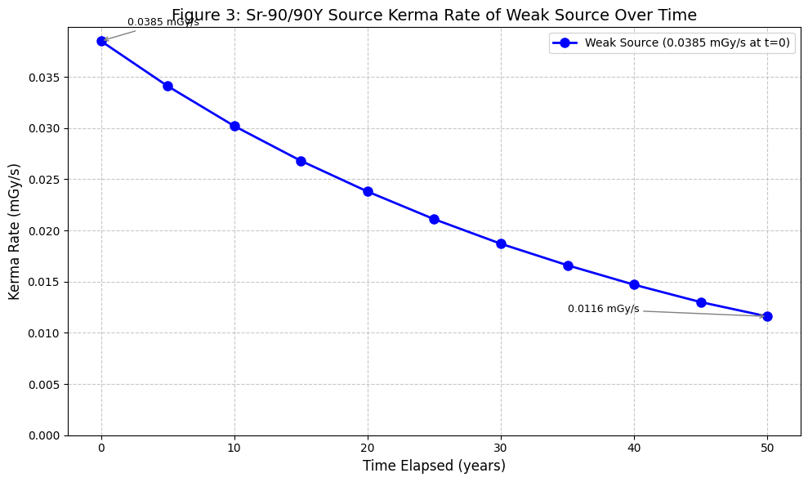
Table 5: Calculated Kerma Rate Equivalent of Strong Sr-90/90Y Source over Time (Based on Gamma Calibration)
Time Elapsed (years) | Relative kerma Rate (%) | Calculated kerma Rate (mGy/s)
0 | 100.0 | 61.21
5 | 88.6 | 54.23
10 | 78.5 | 48.05
15 | 69.6 | 42.60
20 | 61.7 | 37.77
25 | 54.7 | 33.48
30 | 48.5 | 29.69
35 | 43.0 | 26.32
40 | 38.1 | 23.32
45 | 33.8 | 20.69
50 | 30.0 | 18.36
The annual decrease in dose rate is approximately:
Annual decrease=1−e=1-e=1-0.9762=0.0238=2.38%

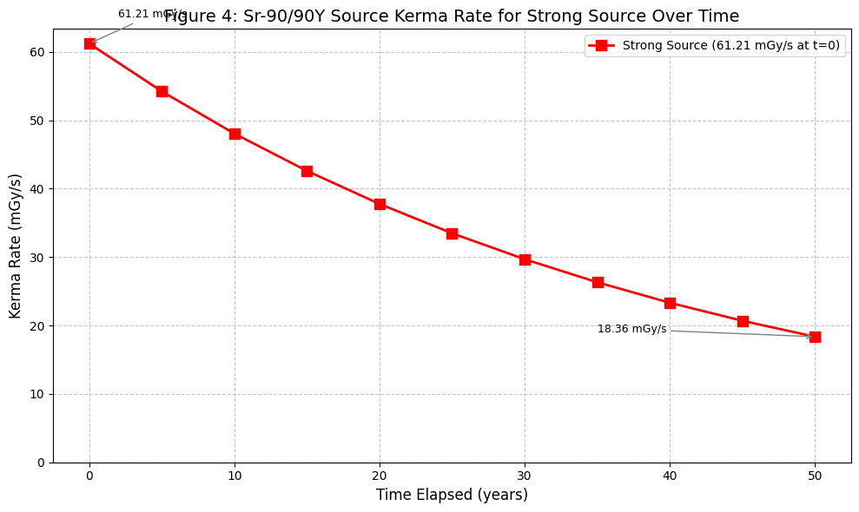

5. Discussion

5.1. Batch Homogeneity and IRF Distribution
The IRF values determined from the uniform gamma irradiation show a range from a minimum of 0.876 to a maximum of 1.158. The distribution of IRF values is roughly symmetric around 1.00. This level of batch uniformity is acceptable for dosimetric applications and allows for effective correction of chip-to-chip variations [3, 4].
The IRF correction reduced the %RSD for the weak source 10-second measurement from 4.46% to 3.13%, representing a meaningful improvement in precision. For the strong source measurements, where statistical uncertainties are smaller, the improvement from IRF correction is less pronounced, as expected.

5.2. Beta Source Linearity
The response of the detectors to the beta source shows excellent linearity with exposure time. For the weak source, the ratio of the 30-second signal to the 10-second signal is 3.08, compared to the expected ratio of 3.00. For the strong source, the ratio of the 15-second signal to the 10-second signal is 1.58, compared to the expected ratio of 1.50.
The slight deviation is within the experimental uncertainty and may be attributed to minor variations in the irradiation geometry or timing between the two exposures.

5.3. Kerma Rate Consistency
The calculated kerma rates for each source configuration show good internal consistency. For the weak source, the kerma rates derived from the 10-second and 30-second exposures are 0.038 mGy/s and 0.039 mGy/s, respectively.
For the strong source, the kerma rates from the 10-second and 15-second exposures are 59.22 mGy/s and 63.20 mGy/s, respectively. The difference is very small and indicates excellent reproducibility at higher kerma rates. The low %RSD value demonstrates the high precision achievable with MCP detectors under controlled conditions [2, 3].
6. Conclusions
The IRF correction proved effective in reducing measurement variability for low-dose beta measurements, confirming the value of this normalization procedure. The detector response to Sr-90/90Y beta radiation was highly linear with exposure time, with signal ratios closely matching expected values, consistent with the linear dose response characteristics of LiF:Mg,Cu,P. The calculated kerma rates for each source configuration were consistent across different exposure times. Regarding source decay, the Sr-90/90Y source decays with a half-life of 28.8 years, corresponding to an annual decrease of 2.38%. The reference dose rates at 19 March 2026 are 0.0385 mGy/s for the weak source and 61.21 mGy/s for the strong source.
The successful completion of this characterization provides a solid foundation for subsequent studies, including the analysis of energy response, fading characteristics, and high-dose behavior of these MCP detectors. The decay calculations presented here will be essential for correcting kerma rates in all future experiments using these sources.

7. References
[1] M. Moscovitch, Personnel dosimetry using LiF:Mg,Cu,P, Radiation Protection Dosimetry Vol. 85, Nos. 1-4, pp. 49-56 (1999).
[2] M. Moscovitch, T. J. St. John et al., The application of LiF:Mg,Cu,P to large scale personnel dosimetry: current status and future directions, Radiation Protection Dosimetry (2006), Vol. 119, No. 1-4, pp. 248-254.
[3] A. Stochioiu, F. Mihai, F. Scarlat, A new passive dosimetric system with thermoluminescent LiF: Mg, Cu, P detectors applied in individual radiation monitoring, Journal of Optoelectronics and Advanced Materials, Vol. 8, No. 4, August 2006, p. 1545-1551.
[4] B. Obryk, H.J. Khoury, V.S. de Barros, P.L. Guzzo, P. Bilski, On LiF:Mg,Cu,P and LiF:Mg,Ti phosphors high & ultra-high dose features, Radiation Measurements, j.radmeas.2014.02.002.
[5] M. Moscovitch, Y.S. Horowitz, Thermoluminescent materials for medical applications: LiF:Mg,Ti and LiF:Mg,Cu,P, Radiation Measurements 41 (2007) S71-S77.
[6] P. Bilski, M. Budzanowski, P. Olko, Dependence of LiF:Mg,Cu,P (MCP-N) glow curve structure on dopant composition and thermal treatment, Radiat. Prot. Dosim. 69, 187-198 (1997).

Report prepared by: Nigus Alene Assefa
Supervisor: dr. hab. Paweł Bilski
Co-supervisor: Dr. Anna Mrozik

